Formatting Template for the CS Project Paper
(revised January 2023)
Student Name: A.N. Other
Supervisor Name: Y.A.A.N. Other
Submitted as part of the degree of BSc Computer Science to the
Board of Examiners in the Department of Computer Sciences, Durham University
Abstract — These instructions give you guidelines for preparing your project report. DO NOT change any settings, such as margins and font sizes. Just use this as a template and modify the contents into your final paper. An abstract should be 100 to 200 words, and should clearly state the nature and significance of the paper. Abstracts must not include mathematical expressions or bibliographic references. Please note that abstracts are formatted as left justified in our editing template (as shown here).
Index Terms—Keywords should be taken from the taxonomy (http://www.computer.org/mc/keywords/keywords.htm). Keywords should closely reflect the topic and should optimally characterize the paper. Use about four key words or phrases in alphabetical order, separated by commas (there should not be a period at the end of the index terms)
xxxx-xxxx/0x/$xx.00 © 200x IEEE Published by the IEEE Computer Society
—————————— ——————————

1 Introduction
T
HIS section briefly introduces the general project background, the research question you are addressing, and the project objectives. It should be around 2 pages in length. Do not change the font sizes or line spacing in order to put in more text.
NOTE: that the whole report, excluding the references, should not be longer than 16 pages in length. It should be noted that not all the details of the work carried out in the project can be represented in 16 pages. You may attach an appendix to the end of your report which will not be marked but provides the markers with additional reference material and context. References to Web based pages should be less than 10% of the total reference count.
NOTE: use the general “IEEE-Trans-Template” as the source for information regarding the formatting of any content not covered in this document.

2 Related Work
This section presents a survey of existing work on the problems that this project addresses. It should be between 2 to 3 pages in length. The rest of this section shows the formats of subsections as well as some general formatting information for tables, figures, references and equations.

2.1 Main Text
The font used for the main text should be Palatino and the font size should be 9.5. The first line of all paragraphs should be indented by 0.5cm, except for the first paragraph of each section, subsection, subsubsection etc. (the paragraph immediately after the header) where no indentation is needed.

2.2 Figures and Tables
In general, figures and tables should not appear before they are cited. Place figure captions below the figures; place table titles above the tables. If your figure has two parts, for example, include the labels “(a)” and “(b)” as part of the artwork. Please verify that figures and tables you mention in the text actually exist. Make sure that all tables and figures are numbered as shown in Table 1 and Figure 1 below.

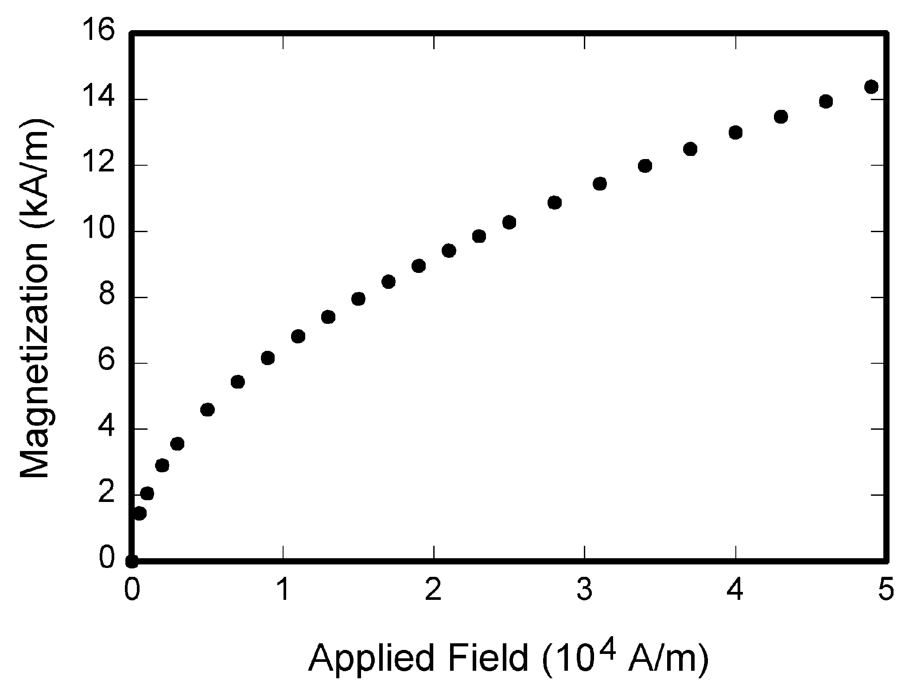
Fig 1. Magnetization as a function of applied field. There is a period after the figure number, followed by two spaces. It is good practice to explain the significance of the figure in the caption

2.3 References
The list of cited references should appear at the end of the report, listed by order of appearance in the paper. The required style is to note citations in individual brackets, followed by a comma, e.g. “[1], [5]” (as opposed to the more common “[1, 5]” form.) Citation ranges should be formatted as follows: [1], [2], [3], [4] (as opposed to [1]-[4]). When citing a section in a book, please give the relevant page numbers [2]. In sentences, refer simply to the reference number, as in [3]. Do not use “Ref. [3]” or “reference [3]” At the beginning of a sentence use the author names instead of “Reference [3],” e.g., “Smith and Smith [3] show ... .”.

3 Methodology
This section presents the solutions to the problems in detail. The design and implementation details should all be placed in this section. You may create a number of subsections, each focussing on one issue.
This section should be between 4 to 6 pages in length.

TABLE 1
Units for Magnetic Properties
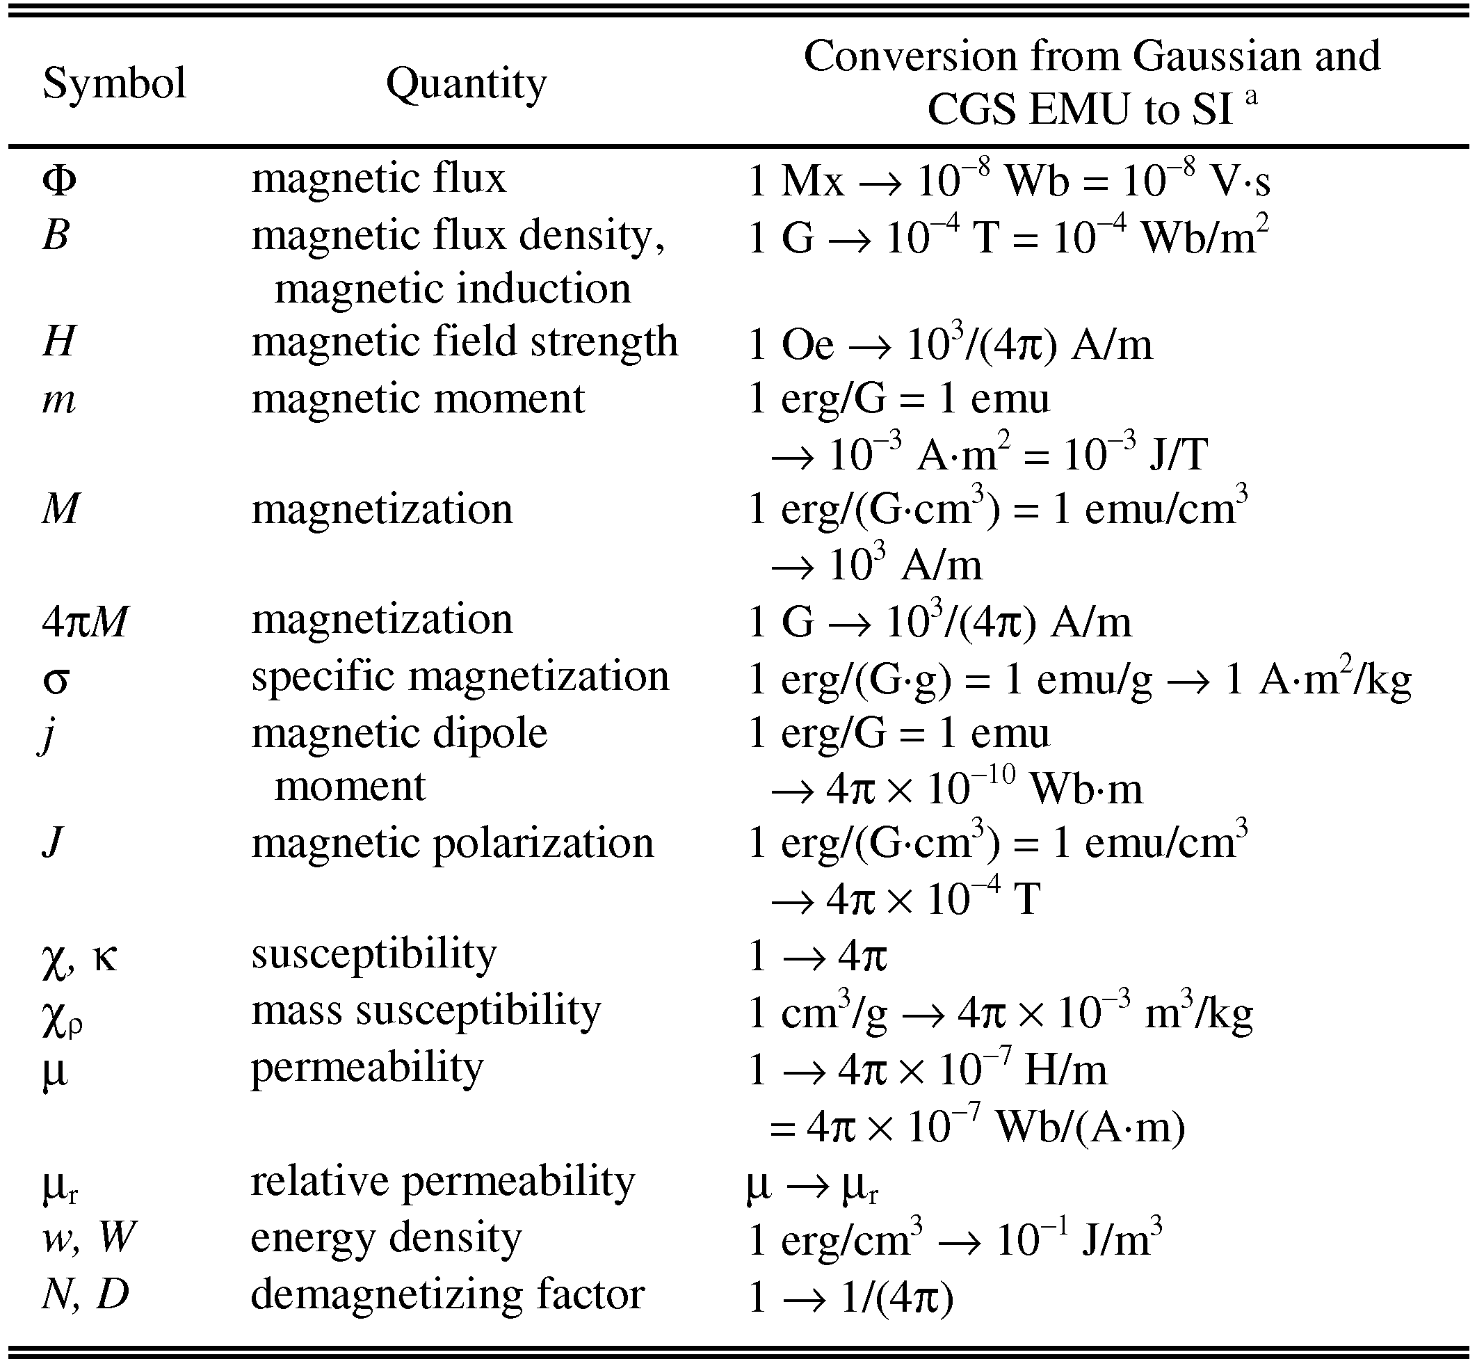
Statements that serve as captions for the entire table do not need footnote letters. E.g. Mx = maxwell, G = gauss, Oe = oersted; Wb = weber, V = volt, s = second, T = tesla, m = meter, A = ampere, J = joule, kg = kilogram, H = henry.

4 Results
This section presents the results of the solutions. It should include information on experimental settings. The results should demonstrate the claimed benefits/disadvantages of the proposed solutions.
This section should be around 2 pages in length.

5 Evaluation
This section should be between 1 to 2 pages in length.

6 Conclusion
This section summarises the main points of this paper. Do not replicate the abstract as the conclusion. A conclusion might elaborate on the importance of the work or suggest applications and extensions. This section should be no more than 1 page in length.
The page lengths given for each section are indicative and will vary from project to project but should not exceed the upper limit. A summary is shown in Table 2.

Table 2:
Summary of Page Lengths for Sections
Section | Number of Pages
I. Introduction | 2
II. Related Work | 2–3
III. Solution | 4–6
IV. Results | 2
V. Evaluation | 1-2
VI. Conclusions | 1

References
- J.S. Bridle, Probabilistic Interpretation of Feedforward Classification Network Outputs, with Relationships to Statistical Pattern Recognition, Neurocomputing—Algorithms, Architectures and Applications, F. Fogelman-Soulie and J. Herault, eds., NATO ASI Series F68, Berlin: Springer-Verlag, pp. 227-236, 1989. (Book style with paper title and editor)
- W.-K. Chen, Linear Networks and Systems, Belmont, Calif.: Wadsworth, pp. 123-135, 1993. (Book style)
- H. Poor, A Hypertext History of Multiuser Dimensions, MUD History, http://www.ccs.neu.edu/home/pb/mud-history.html. 1986. (URL link *include year)
- K. Elissa, An Overview of Decision Theory, unpublished. (Unpublished manuscript)

